KSB TEMPLATE SAMPLE ENTRIES
(LEARNING JOURNAL)

This document provides some examples of what learning journal entries might look like as you progress through your programme.
It is expected that they will vary in nature. Some may be very short reflections based on new learning you encounter in your workplace or at university. Some may be more significant pieces of evidence that could relate to multiple KSBs.

KNOWLEDGE

K6 | KNOWLEDGE
Criteria | The approaches and techniques used throughout the digital and technology solution lifecycle and their applicability to an organisation’s standards and pre-existing tools.
This KSB will be assessed at EPA via your PORTFOLIO | K6.1  29th November 2025 – workplace experience with GitHub  In my first month I was assigned to work on project X at my workplace and learned how to make git contributions to an existing code repository, as shown in the screenshot provided. I also learned how Pull Requests (PRs) are useful in receiving feedback on code before merging into the main branch. Explainer: A Pull Request is a way for a developer to propose merging changes from one branch into another, usually the main codebase. Before the code is merged, teammates can review it, leave comments, and request changes if needed. It's a really useful process for catching bugs early and making sure the code meets the project's standards before it goes live.  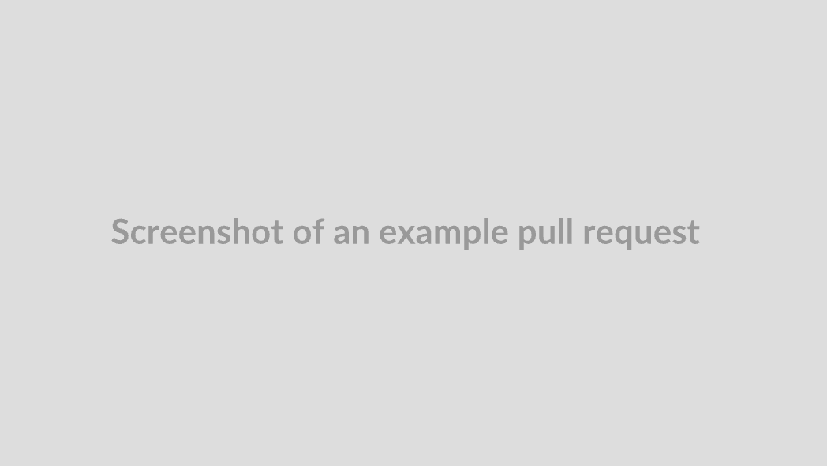  Example of how I merged a pull request into the main branch of the project I am working on within my workplace:  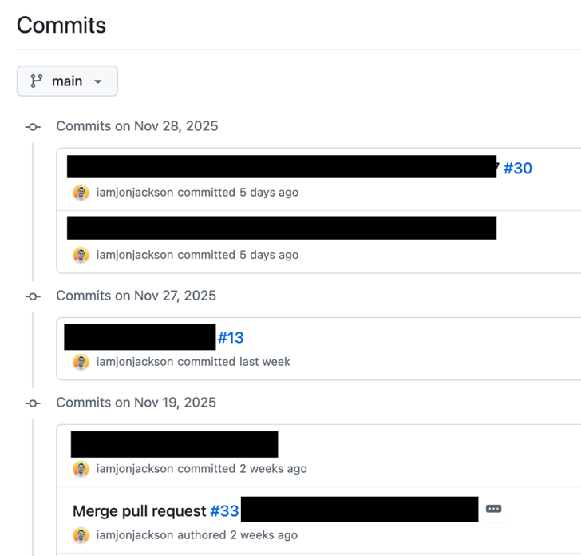  K6.2  20th January 2026 – Scrum workshop at work  Attended a training workshop at work on Scrum and Agile. I already knew the basics of Scrum but I learned how we are meant to carry out sprint retrospectives at our workplace which was new to me. For example, we have a specific time allotted in the sprint retro for junior team members to contribute their feedback which I think is valuable. I will make sure to try and voice my opinions when I can. I think this might link to KSB B6 because if I learn something new at uni that I think might benefit the way the team works I could voice it in the retrospective or maybe discuss with my line manager first.  K6.3  2nd February 2026 – working on Jira  - Using Jira at work recently helped me understand the different phases in the product lifecycle like planning, development, and testing (we have different columns on the kanban board we use for each phase). We actually have separate phases or states within that fall under “testing” e.g. acceptance  - I learned how the tool supports the company’s dev standards by setting up workflows within Jira to automate and enforce the steps needed to get a task through User Acceptance Testing (UAT).  - Important learning: Traceability matters! Jira not just for task management.  - Screenshots below of our Jira board from Project Alpha with several tasks assigned to me and a screenshot of a workflow I helped setup:    K6.4  3rd October 2026 – wrote my first full backlog task  To write the following task definition, I had to speak to 3 different stakeholders and collate their requirements and produce the final task definition which then needed to go to them for approval before I could change its status to “ready” on Jira. I learned how important it is to get a task definition as close to correct as possible.    K6.5  22nd October 2026 – backlog task refinements  Even though the task definition I wrote for K6.4 was signed off by the necessary stakeholders, there ended up being additions and changes needed once development started! We had a process to deal with this though and while I was a bit annoyed at having to update the task after putting so much work into it, I realised this part of working in an agile way. I also realised there were some questions I could have asked earlier on which would have elicited more information from the stakeholders and helped reduce the number of changes that were needed mid-sprint.  [EXAMPLE QUESTIONS HERE]

K8 | KNOWLEDGE
Criteria | How teams work effectively to produce digital and technology solutions.
This KSB will be assessed at EPA via your PORTFOLIO | K8.1  3rd Dec 2026 – using MS Teams chat  I have become comfortable asking colleagues questions via MS Teams chat which is the tool we use internally for instant messaging.  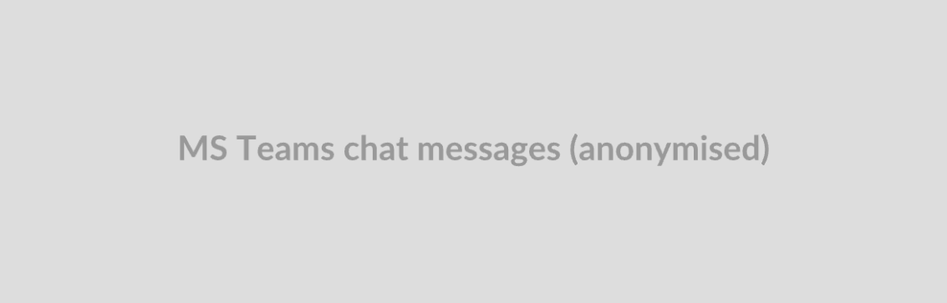  We also have several large group chats where we can ask questions or request support across the team. Here’s me asking a question and getting support from one of my helpful colleagues:    K8.2  2nd February 2026 – working on Jira  (see K6.3)  INSERT A SHORT EXPLANATION OF THE RELEVANCE OF THE EVIDENCE TO THIS KSB  K8.3  10th March 2026 – experienced pair programming  Pair programming for the first time! Challenging and eye-opening. We were sitting side by side sharing the same screen and keyboard. (I’ve heard some companies do pair programming remotely, but I haven’t got my head around that yet.) We swapped between driver and navigator roles every 20 minutes. At first, it felt awkward because I wasn’t used to explaining my thought process out loud while coding and it was strange to keep switching from writing code to observing. I realised how much I normally work in my own head. Having to talk through each step made me think more carefully about why I was doing things. It also helped me spot mistakes earlier because my partner would question things I overlooked. I learned that collaboration isn’t just about splitting tasks, it’s about sharing ideas and improving each other’s approach. I learned a lot when my partner was “driving” and by the end of the day, I already started to feel more confident in my own coding and explaining things logically when I was driving. Can see how it helps develop cleaner, more maintainable code.  Explainer: Pair Programming is when two developers work together at the same workstation, with one person writing the code (the "driver") and the other reviewing and guiding in real time (the "navigator"). The roles are typically swapped regularly so both people stay engaged. I have also learned about Mob Programming which is like pair programming but with the whole team — one person types while everyone else collaborates and contributes ideas together in real time.

K9 | KNOWLEDGE
Criteria | The concepts and principles of leadership.
This KSB will be assessed at EPA via your PORTFOLIO | K9.1  14th Feb 2026 - project manager handling uncertainty during a project restructure.  During a period where our team was told that project priorities were shifting but no firm details had been confirmed yet, I noticed how our project manager handled the ambiguity really well. Rather than waiting until everything was finalised, she called a short team meeting to acknowledge that things were uncertain, was honest about what she didn't know yet, and reassured us that she would communicate updates as soon as she had them. She also made a point of checking in with individuals one-to-one over the following days. At the time I didn't think too much of it, but reflecting back, this was a strong example of transparent and people-centred leadership. I feel like she prioritised psychological safety over pretending to have all the answer, which kept the team calm and focused. It could have been a lot more stressful than it was. It made me realise that good leadership isn't always about having the answers.  K9.2  6th April 2026 - leadership theories and styles  Recent lecture notes:  - Transformational leadership focuses on inspiring and motivating people through a shared vision, whereas Transactional leadership is more focused on structure, rewards, and performance targets  - Situational leadership - there is no single "best" style and that effective leaders adapt their approach depending on the competence and confidence of the individual they're leading  - Servant leadership flips the traditional hierarchy, with the leader seeing their primary role as supporting and enabling their team.  Reflection: Having thought about this, I think I most identify with a mix of Transformational and Servant leadership. In my current role, I naturally tend to focus on understanding what people need to do their best work and trying to remove blockers for them, which aligns with the Servant model. But I'm also motivated by the idea of working towards a bigger purpose, which draws me towards the Transformational style. I'm less drawn to a purely Transactional approach, though I can see its value in structured environments where clear targets and accountability are important.  K9.3  3rd September 2026 – reflections on a difficult team situation  I reflected on this event using Gibbs:  - Description: During a recent project, our team was working to a tight deadline but there was no clear owner for a key deliverable. Two senior colleagues had different views on how it should be approached and neither stepped up to make a final call, which left the rest of the team unsure whose direction to follow.  - Feelings: I found the situation quite frustrating, and I noticed it was affecting the team's confidence too. I wasn't sure whether it was my place to say anything as I’m still a junior member of the team, but I felt uncomfortable just watching things stall.  - Evaluation: The lack of decisive leadership had a real impact. Work was being duplicated and the atmosphere in stand-ups became tense. On the other hand, it was a useful situation to observe because it highlighted exactly what can go wrong when accountability isn't clearly defined.  - Analysis: Reflecting on this, I think the root issue was that neither colleague felt fully empowered to lead, possibly because roles hadn't been clearly defined at the start of the project. Maybe they lacked confidence too. I don’t think they see themselves as “management” so this may have held them back from taking action. This links to what I'd learned about Situational Leadership - a good leader reads the room and steps up when clarity is needed, even if it's uncomfortable.  - Conclusion: Leadership isn't always a formal title, sometimes it means being the person who brings a bit of structure to a chaotic situation. I also recognised that I could have done more myself, for example by suggesting the team align on a decision-making process.  - Action Plan: Going forward I want to be more proactive in flagging ambiguity early, and as I build my confidence, I want to practise helping others achieve agreement (consensus?) in situations where there's no clear lead. I will talk to my line manager about this and ask for further advice on how I can communicate more effectively in different situations so I can start to demonstrate leadership in small ways.

SKILLS

S10 | SKILL
Criteria | Initiate, design, implement and debug a data product for a digital and technology solution.
This KSB will be assessed at EPA via your PORTFOLIO | S10.1  1st Feb 2026 - SQL debugging from IOT123 module  Despite being new to SQL at the beginning of this module, during these exercises I found debugging most of the SQL statements a lot more straightforward than I expected which helped my confidence. I learned how to read and interpret error messages more carefully and error messages scare me less now!  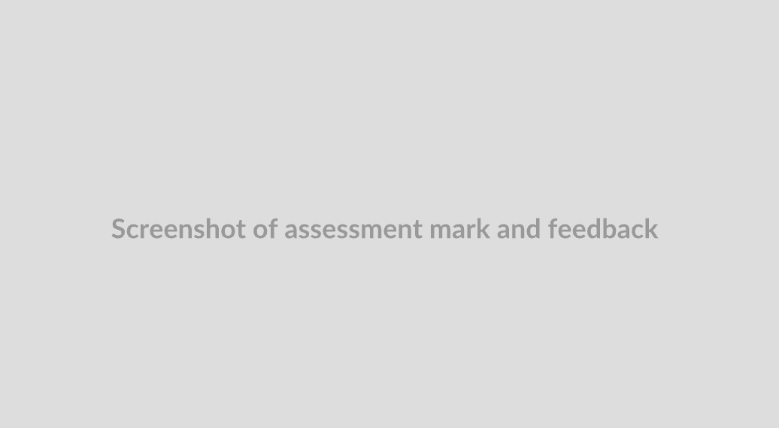  S10.2  20th May 2026 – IOT123 Database Solution Assessment  I achieved 80% on my database solution assessment for module IOT123 as evidenced in the screenshot below which also included feedback:  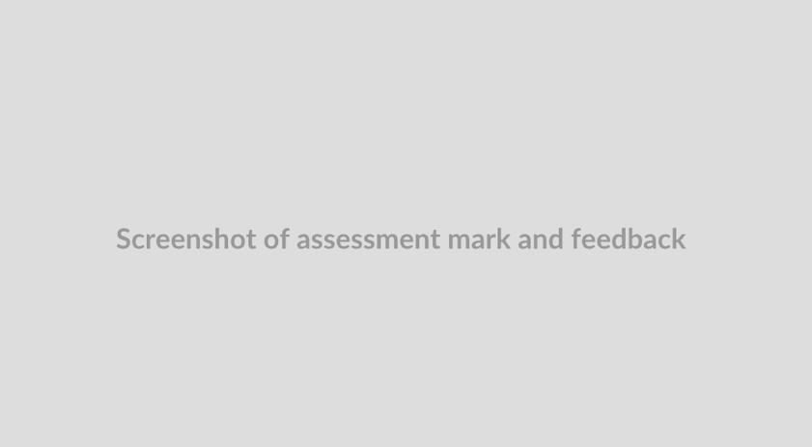  In this project I produced a full database using MySQL as well as a front-end dashboard using PowerBI. The dashboard helped solve the problem of… [EXPLAIN IN A SHORT PARAGRAPH]. Alternatives to PowerBI were… [ALTERNATIVES]… but I chose PowerBI because… [EXPLAIN]  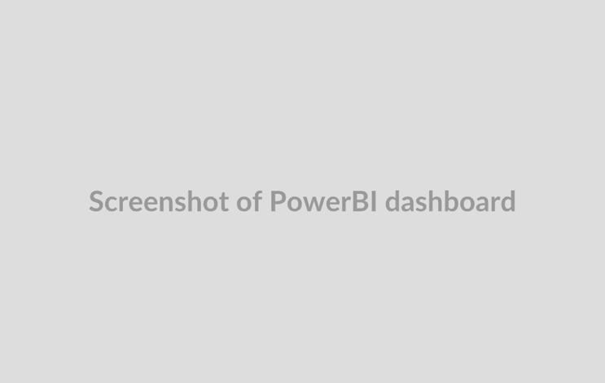

S13 | SKILL
Criteria | Report effectively to colleagues and stakeholders using the appropriate language and style, to meet the needs of the audience concerned.
This KSB will be assessed at EPA via your PROJECT | S13.1  12th Feb 2026 – Jira ticket write-up  I had to write a ticket for our current work project by following the guideline template and ensuring technical detail was included for my software engineering colleagues working on the task. The ticket was moved from DRAFT to NEXT UP by my manager demonstrating acceptance of the write-up:    S13.2  3rd July 2026 – project report produced for Project ZYX  - Produced a project status report for a mixed audience of technical developers and senior business stakeholders, requiring two distinct sections written in different styles and levels of detail  - Used plain, jargon-free language in the executive summary to ensure senior stakeholders could quickly understand the project's current position and any risks without needing technical knowledge  - Included a more detailed technical appendix for the development team, covering specific system dependencies and integration issues that were relevant to their work  - I replaced a dense table of figures with a simple RAG (Red, Amber, Green) status chart, making it immediately clear to stakeholders which workstreams were on track and which needed attention. I intend to use a similar approach in my final project report next year.    - I next circulated a draft to a colleague before the final submission to check the tone and clarity were appropriate for the intended audience  - Evidence of effectiveness: I received confirmation from the project manager that the report was used directly in a board-level update, indicating the content and style were fit for purpose

BEHAVIOURS

B6 | BEHAVIOUR
Criteria | Participates in and shares best practice in their organisation, and the wider community for aspects relevant to digital and technology solutions.
This KSB will be assessed at EPA via your PORTFOLIO | B6.1  20th Aug 2026 – ran a lunch-and-learn for writing clear user stories  - Situation: Our team noticed that requirements were frequently being misunderstood between the business and development teams, leading to rework and delays during sprints.  - Task: As the BA on the team, I wanted to find a way to address this and share what I'd learned with colleagues beyond just my immediate project.  - Action: I put together a short internal lunch-and-learn session where I walked through some best practices for writing clear user stories, including how to structure acceptance criteria using the Given/When/Then format. There was an existing culture of lunch-and-learns across our department so it made sense to use this as a way of sharing best practice. I also shared a template I'd created and encouraged other BAs to adapt it for their own projects. Afterwards, I posted the materials to our shared Confluence space so the wider team could reference them (see screenshot below).  - Result: A colleague from another project team adopted the template and fed back that it had helped reduce ambiguity in their own sprint planning sessions (see their feedback below).  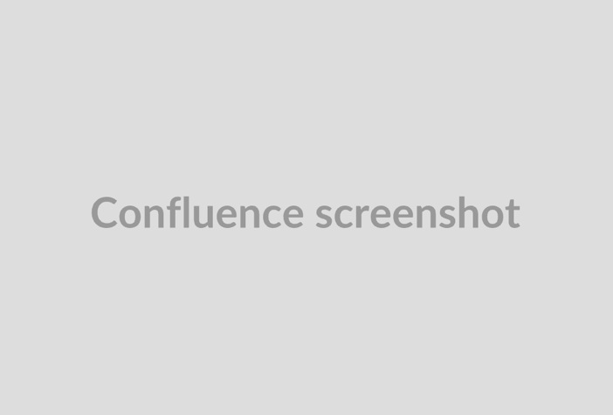  

B8 | BEHAVIOUR
Criteria | Champions diversity and inclusion in their work ensuring that digital technology solutions are accessible.
This KSB will be assessed at EPA via your PORTFOLIO | B8.1  1st August 2025 – mandatory training at work  As part of my employment onboarding I had to complete a series of mandatory training courses, one of which was “Diversity and Inclusion in the workplace”. Evidence of completion:  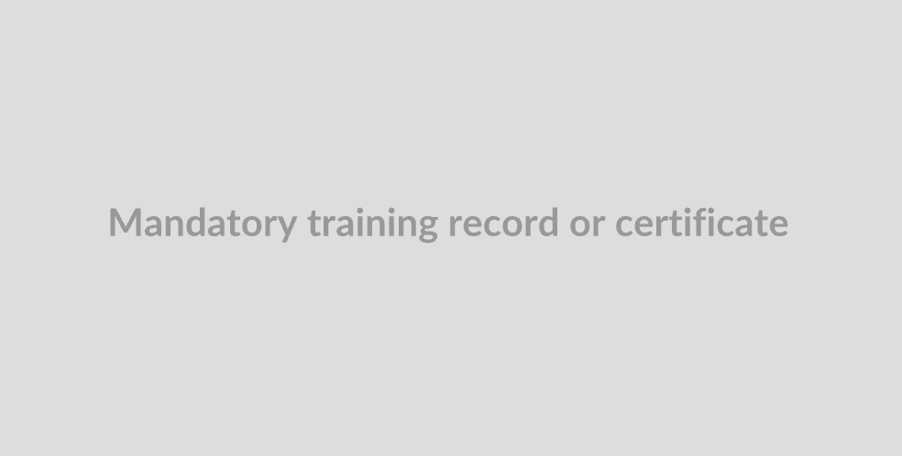  At this stage I am not sure how I will become a “champion” for diversity and inclusion, but I will talk to my team about initiatives I might be able to get involved with.  B8.2  10th Jan 2026 – web accessibility webinar  I attended a web accessibility webinar hosted by Google which I really enjoyed. I made the following notes on my key learnings:  - Understanding the importance of semantic HTML (e.g. using <button> instead of <div>) for screen reader compatibility  - Learning about WCAG guidelines and what the different conformance levels (A, AA, AAA) mean in practice  - How colour contrast ratios affect readability for visually impaired users  - The role of alt text on images and how to write it effectively  - How to navigate a webpage using only a keyboard, and why tab order matters  - accessibility benefits everyone, not just users with disabilities    B8.3  20th Aug 2026 – Participated in digital accessibility working group    B8.4  1st July Aug 2027 – Manager feedback on accessibility work for Project XYZ  I feel a lot more confident in my accessibility knowledge now that I have been able to apply it in a specific project and received positive feedback from my manager (below).  